# Improve

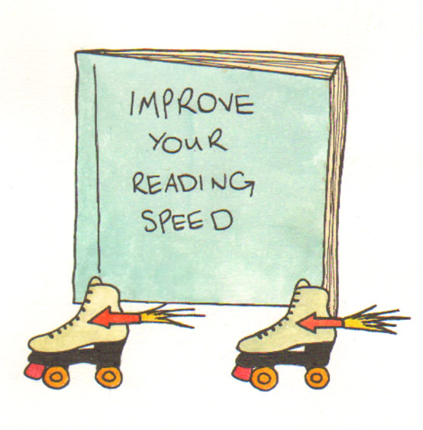

# your reading speed

## 3 things you need to know:

**fixation: the amount of time you spend looking at each word**



**regression: re-reading text that has already been read**



**sub-vocalisation: or unknowingly reading aloud**



**fixation: the amount of time you spend looking at each word**



**Your eyes do not move smoothly along a line of text, they ‘jump’ from word to word.**

**Many . studies . have . suggested . that the shorter the word is, the more likely it is to be skipped.**

**The stop you make between each word is called a fixation. Slower readers fixate or stop for longer between each word.**

**regression: re-reading text that has already been read**



**Regression happens when your eyes flick to the left – and you begin to re-read words that you have already looked at.**

**Poor readers regress frequently, often to the beginning of the sentence or paragraph.**

**sub-vocalisation: or unknowingly reading aloud**



**When we learn to read as children we are encouraged to read aloud. As we get older we learn to read silently. However we still make almost invisible lip movements without being aware of this. Poor readers still read ‘under their breath’ or ‘whisper’ the words whilst reading, some mouth them silently. This takes extra time and slows reading down.**



**Our eyes are naturally attracted to motion – it’s easy to be distracted by someone or something moving in your environment, this makes reading more difficult when you are trying to concentrate.**

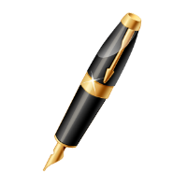

**Using a pen or your finger to follow along a line of text satisfies our attraction to motion, and can stop you fixating, regressing and vocalising.**

## Practice:

**If you move the pen or your finger along the line slightly faster than you are used to, it pushes your eyes to move across the words without stopping.**

**It also prevents your eye from jumping backwards, and you have less time to attempt to read the words aloud.**



**You can increase your speed by practising this every day using a ‘drill’.**

1. **Choose a piece of text or page from a book.**
2. **Use the pen / finger technique and see how many words you can complete in one minute.**
3. **Stop the watch and mark the last word you have read.**
4. **Do this again with the same piece of text and see if you manage to read a few more words and therefore a little faster.**